**DSC 465 – Data Visualization**

**Global Insights into Suicide Rates**

**An Overview of Trends, Demographics, and Economic Factors**

**Sai kiran Bommena**

**Vamsi Routhu**

**Avinash Betha**

**Table of Contents**

* Introduction
* Data and Methodology
* Exploratory Analysis
* Explanatory Analysis
* Analysis and Discussion

**Introduction**

This report aims to present the final visualizations designed for analyzing suicide rates across various demographic and socioeconomic factors. It outlines specific visualizations intended to explore patterns in key areas, including sex by age group, country generation, income group, economic performance, and age range within countries.

According to the National Institute of Mental Health (NIMH), suicide is a significant public health concern, with suicide being a leading cause of death in the United States. Recent national surveys have highlighted a concerning rise in suicide rates among certain populations. This study seeks to address this pressing health issue from a global perspective.

To achieve this objective, we utilize a comprehensive dataset sourced from Kaggle, a renowned datasets and data analysis platform. The dataset provides a rich source of information that allows for an in-depth examination of suicide rates across various demographic and socioeconomic dimensions.

[Link to the dataset: <https://www.kaggle.com/code/kralmachine/data-visualization-of-suicide-rates/input>]

By leveraging the power of data visualization and statistical analysis, this report endeavors to uncover insights into the complex factors influencing suicide rates worldwide. Through a detailed examination of the data, we aim to contribute to a better understanding of this critical public health issue and inform evidence-based interventions and policies aimed at reducing suicide rates and supporting vulnerable populations.

**Data and Methodology**

The dataset utilized in this analysis comprises information from 101 countries from 1985 to 2016. It encompasses several key variables:

**Country:** Represents 101 countries included in the dataset.

**Year:** Encompasses the period from 1985 to 2016.

**Sex:** Categorized into male and female.

**Age:** Segmented into six groups, starting from age 5, reflecting different life stages.

**Suicide Rate per 100k Population:** Indicates the number of suicides per 100,000 individuals.

**Generation:** Classifies the population born between 1901 and 2012 into six generational groups.

**Income Group:** Classifies countries into four income level categories.

The age groups are delineated based on the year of birth, with the following classifications:

**G.I Generation:** Born between 1901 and 1927.

**Silent Generation:** Born between 1928 and 1945.

**Boomer Generation:** Born between 1946 and 1964.

**Generation X:** Born between 1965 and 1980.

**Millennials:** Born between 1981 and 1996.

**Generation Z:** Born between 1997 and 2012.

Age groupings range from 5-14, 15-24, 25-34, 35-54, 55-74, and 75+, likely reflecting distinct life stages and associated stress levels.

**Purpose of Analysis:**

This analysis endeavors to uncover and elucidate patterns across four primary areas:

**Global Suicide Rate Trends:**

**Objective:** Analyze trends in global suicide rates from 1985 to 2016.

**Data Analysis:** Line graphs were employed to visualize changes in suicide rates over time. Each line represents the suicide rate trend for a specific year, offering a clear depiction of the overall trajectory of global suicide rates during the specified period.

**Suicide Rates by Gender:**

**Objective:** Investigate suicide rates by gender.

**Data Analysis:** Bar charts were utilized to compare suicide rates between male and female populations. The height of each bar represents the suicide rate for a particular gender, facilitating easy comparison between the two groups.

**Age and Gender-Specific Suicide Rates:**

**Objective:** Analyze suicide rates by age group and gender.

**Data Analysis:** Stacked bar charts were employed to compare suicide rates across different age groups and genders. Each bar is segmented to represent different age groups, enabling a visual comparison of suicide rates within each gender category.

**Economic Factors and Suicide Rates (G20 Countries):**

**Objective:** Explore the relationship between economic indicators and suicide rates within G20 countries.

**Data Analysis:** Dual-axis line graphs were utilized to visualize the relationship between economic indicators and suicide rates. One axis represents economic indicators (e.g., GDP per capita, unemployment rate), while the other axis represents suicide rates. This visualization technique allows for a clear comparison between economic trends and suicide rates over time within G20 countries.

**Suicide Rates by Generation:**

**Objective:** Examine suicide rates across different generational cohorts.

**Data Analysis:** Bubble charts were utilized to visualize suicide rates by generation. Each bubble represents a generational cohort, with the size indicating the relative suicide rate for that generation. This visualization allows for a comparison of suicide rates across different generations in a visually engaging manner.

**Country-Specific Insights:**

**Objective:** Gain insights into variations in suicide rates across different countries.

**Data Analysis:** Choropleth maps were employed to visualize suicide rates across countries. Each country is shaded according to its suicide rate, facilitating easy identification of countries with higher or lower suicide rates.

**Generations Suicide Rate Among Countries:**

**Objective:** Investigate how generational suicide rates vary across countries.

**Data Analysis:** Choropleth maps were utilized to visualize suicide rates among different generational cohorts within individual countries. Each country is shaded according to the suicide rate of the specific generational cohort, providing insights into cross-national variations in generational suicide rates.

Using diverse data visualization techniques, this study aims to provide comprehensive insights into global suicide trends and the factors influencing suicide rates across various demographic and socioeconomic dimensions.

**Exploratory Analysis**

As a team, we performed a vast amount of exploratory analysis. The following includes just a few sample visualizations created during this process which helped guide our explanatory visualizations.

**About G20:**

G20 has two-thirds global population represents about 90% of the global Gross Domestic Product and about 80% of international trade. It contains advanced economies, emerging economies (defined by IMF), as well as the largest developed country (U.S.), and the largest developing country (China). Variation and comprehensiveness make G20 a great representative for a detailed analysis.

**Distribution of Suicide Rates per 100k Population**

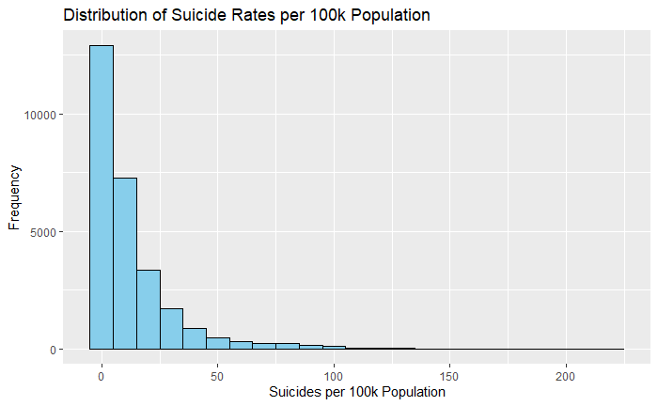

In our project, we explore the distribution of suicide rates per 100,000 population, as visualized through a histogram. The data indicates a skew towards lower suicide rates, with most regions displaying rates close to zero. This suggests that lower suicide rates are more common. However, there is a notable decrease in the number of regions as suicide rates increase, with higher rates being much rarer. The absence of clusters at the higher end of the scale could indicate that very high suicide rates are exceptional and possibly linked to specific regional factors. These findings highlight the importance of localized strategies for suicide prevention and suggest a need for further investigation into the factors that contribute to the variance in suicide rates. The analysis also raises questions about the potential underreporting in regions with anomalously low suicide rates. This exploratory study forms a basis for more in-depth research and underscores the complex nature of mental health issues across different populations.

**Suicide Rates per 100k Population by Gender**

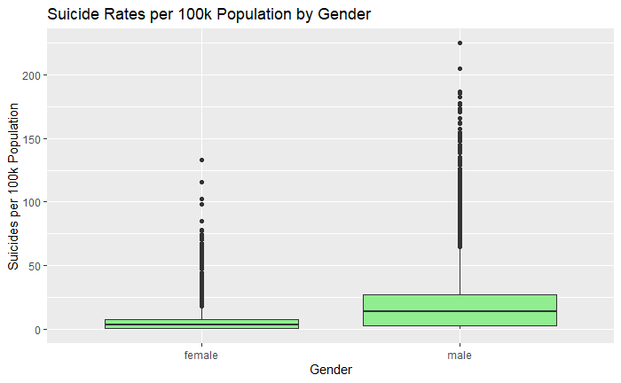

Our project's box plot analysis reveals significant differences in suicide rates per 100,000 population between genders. Females show lower median rates and less variability, while males have a higher median and greater range, suggesting more pronounced differences in suicide frequency. Notably, male outliers indicate extreme values, hinting at higher suicide instances in some male demographics. This visual comparison highlights the necessity for gender-specific mental health interventions and underlines the importance of addressing gender factors in public health strategies.

**Suicide Rates per 100k Population vs. GDP per Capita**

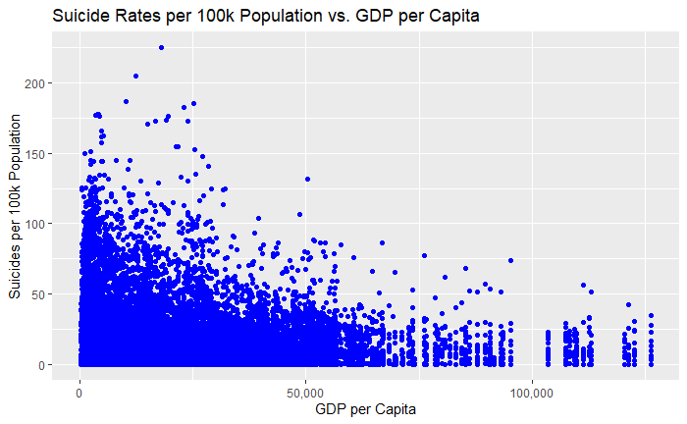

Our scatter plot analysis illustrates the relationship between suicide rates per 100,000 population and GDP per capita. The data points, representing various geographical entities, do not exhibit a clear correlation between higher GDP and suicide rates. A dense concentration of data at the lower end of the GDP spectrum suggests that lower economic wealth does not necessarily correlate with higher suicide rates. Conversely, at higher GDP levels, there is a dispersion of suicide rates, indicating that higher economic status is not a definitive protective factor against suicide. The spread of data points across the economic spectrum emphasizes the multifaceted nature of suicide as a public health issue, transcending economic boundaries. This analysis highlights the complexity of the relationship between economic factors and mental health, reinforcing that suicide prevention strategies must consider a wide array of socioeconomic factors.

**Total Suicides by Generation**

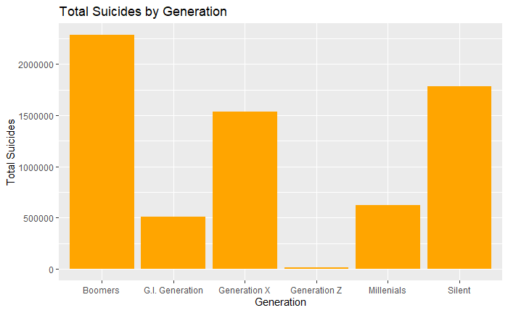

The bar chart we have analyzed represents total suicides classified by generational cohorts: Boomers, G.I. Generation, Generation X, Generation Z, Millennials, and the Silent Generation. From the data, the Boomer generation exhibits the highest total number of suicides, followed by Generation X and the Silent Generation, with the latter two displaying relatively less but still substantial numbers. Notably, the Millennials and Generation Z have significantly lower totals, which could be attributed to the younger age of these populations at the time of data collection.

This generational perspective on suicide rates indicates potential historical, cultural, and socioeconomic factors that may influence mental health outcomes across different age groups. It suggests the need for tailored prevention strategies that address the unique challenges and life experiences of each generation. The marked difference between generations in total suicide numbers also invites further exploration into the impact of changes in societal norms, support systems, and mental health awareness over time.

**Scatter plot matrix for numerical variables**

The scatter plot matrix in our analysis provides a visual comparison across multiple variables related to suicide rates. It highlights the nuanced relationship between population size and suicide numbers, indicating a general trend where larger populations may see a greater number of suicides, yet this relationship is not strictly linear, suggesting the influence of additional factors. When assessing suicide rates per 100,000 people, the normalization across populations points to varying suicide rates that do not correlate directly with population size, indicating that other variables play a role. Furthermore, the data does not support a straightforward relationship between economic indicators such as GDP for the year or GDP per capita and suicide rates, challenging the assumption that economic prosperity is directly related to lower suicide incidences. This complexity reinforces the need for a holistic approach to understanding and preventing suicide, one that encompasses economic, social, and healthcare dimensions.

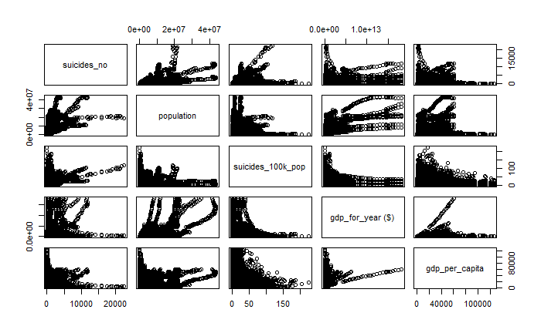

**Correlation matrix**

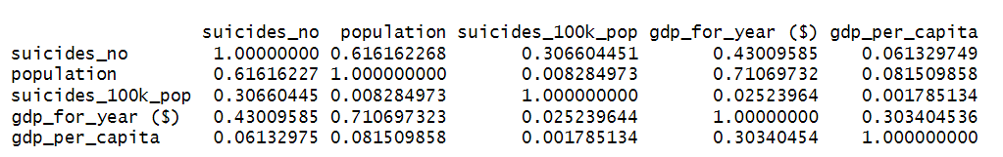

Our statistical analysis has produced a correlation matrix that assesses the relationships between the number of suicides, population size, suicide rates per 100,000 population, and GDP figures (both total for the year and per capita). The correlation values range from -1 to 1, where 1 denotes a perfect positive correlation, -1 indicates a perfect negative correlation, and values close to 0 suggest no linear correlation.

The data reveals that the total number of suicides ('suicides_no') and the population size have a moderately strong positive correlation of approximately 0.62, indicating that as the population increases, the number of suicides tends to increase as well, albeit not strictly proportionally. The correlation between 'suicides_no' and the normalized 'suicides_100k_pop' is weaker, around 0.31, suggesting other factors are influential in the suicide rate beyond just population size.

Interestingly, 'gdp_for_year' shows a substantial positive correlation with population size (0.71), which is expected as larger populations often have higher GDPs. However, the correlation of GDP (for the year and per capita) with 'suicides_no' and 'suicides_100k_pop' is notably low (ranging from 0.06 to 0.43), revealing that economic factors as measured by GDP are not strong predictors of suicide frequency or rate.

These findings highlight the complex interplay between socioeconomic indicators and public health outcomes, such as suicide rates. They caution against simplistic conclusions about wealth and well-being and point towards the need for more nuanced analyses that incorporate a variety of socio-economic, cultural, and psychological factors when devising strategies to prevent suicides.

**Explanatory Analysis**

**Global Suicide Rate Trends**

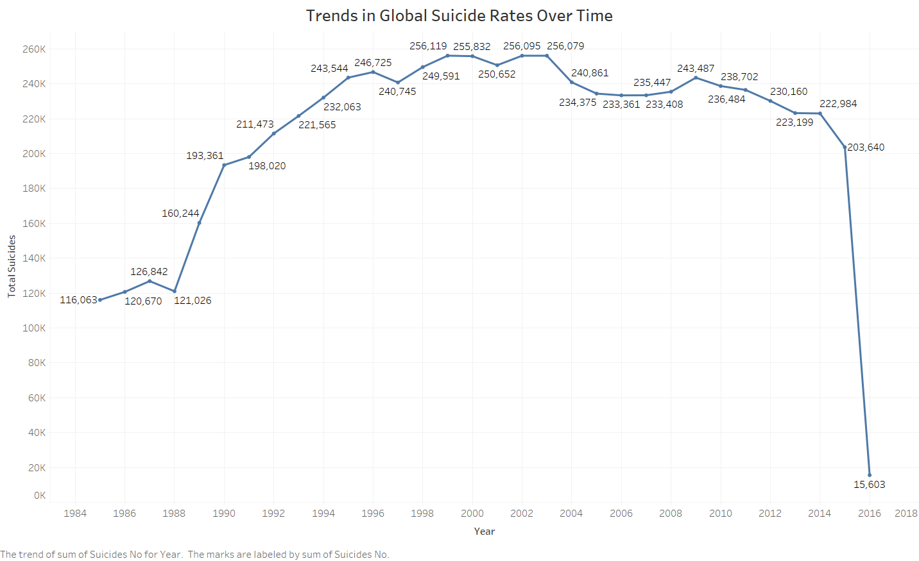

The line graph we have prepared encapsulates global suicide trends from 1984 to 2018, revealing an initial upward trajectory in total suicides, stabilizing in the early 2000s. The consistency in numbers during the plateau phase may reflect various global efforts at suicide prevention, as well as demographic and societal shifts.

However, the data shows an unexpected and sharp decline in reported suicides by 2018. This outlier in the trend necessitates a careful examination of potential factors, such as methodological changes in data recording or genuine reflections of the impact of global mental health initiatives.

In interpreting this graph, it is imperative to consider broader global contexts, including health policy developments, economic fluctuations, and advancements in societal attitudes toward mental health. The dramatic drop seen in the latest data point underscores the need for additional scrutiny to confirm the authenticity of the trend and to understand the full scope of contributing factors. This graph is a crucial element in assessing the effectiveness of ongoing strategies for suicide prevention and mental health support worldwide.

**Suicide Rates by Gender**

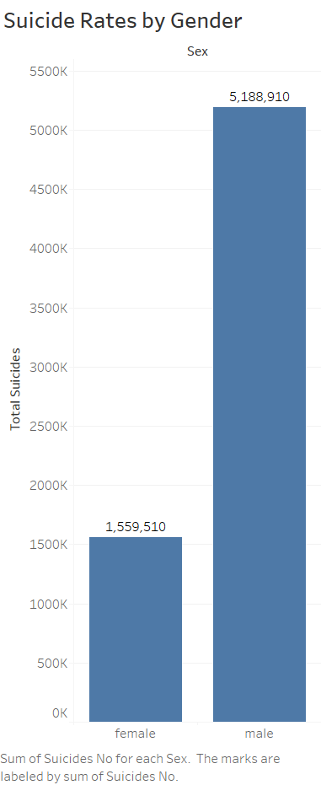

The bar chart provides a stark visual representation of suicide rates differentiated by gender. It depicts a comparison between the total number of suicides among females and males. The data show that the total suicides among males (5,188,910) are substantially higher than among females (1,559,510).

This significant disparity underscores a gender gap in suicide occurrences, highlighting the necessity for gender-specific mental health interventions and research. The reasons behind this gap may be multifaceted, including biological, social, and psychological factors that differentially impact males and females.

Understanding these underlying factors is crucial for developing targeted prevention strategies. The chart effectively draws attention to this gendered aspect of public health, suggesting a pivotal area for further exploration and action within the realm of mental health services and policy-making.

**Age and Gender-Specific Suicide Rates**

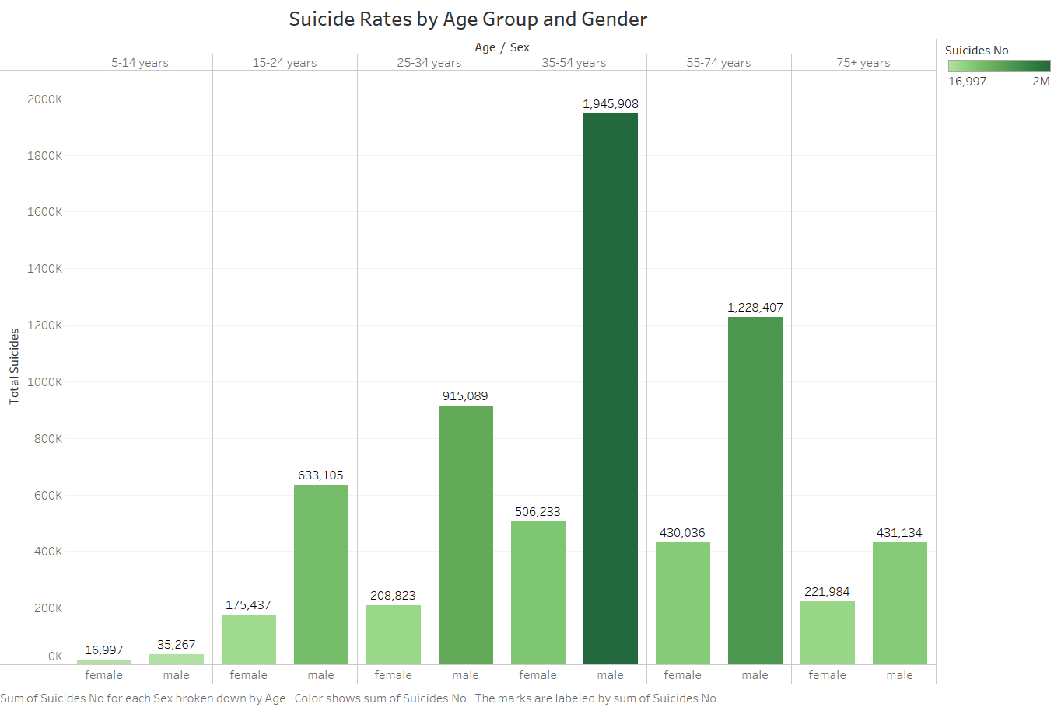

The above bar chart displays the total number of suicides segmented by age group and gender, providing a comprehensive view of suicide demographics. The age groups range from 5-14 years up to 75+ years. The data reveals that suicide numbers increase with age, with the highest numbers reported in the 35-54 and 55-74 age brackets for both females and males.

Notably, within every age group, male suicides outnumber female suicides. The difference is most pronounced in the 35-54 age range, where the male suicide count is nearly double that of females. The trend continues in the 55-74 age bracket, albeit with a slightly smaller margin.

The youngest age group, 5-14 years, has the lowest counts for both genders, suggesting that suicide is less common in this demographic. Conversely, the 75+ years group also shows a significant number of suicides, particularly among males, indicating that elderly populations remain a crucial demographic for suicide prevention efforts.

This age and gender-based analysis provides vital insights into the prevalence of suicide across different stages of life. It emphasizes the need for targeted mental health initiatives that cater to the specific risk factors associated with each demographic. The data highlights the importance of gender-sensitive approaches, as males consistently show higher suicide rates, underscoring a critical area for intervention.

**Economic Factors and Suicide Rates (G20 Countries)**

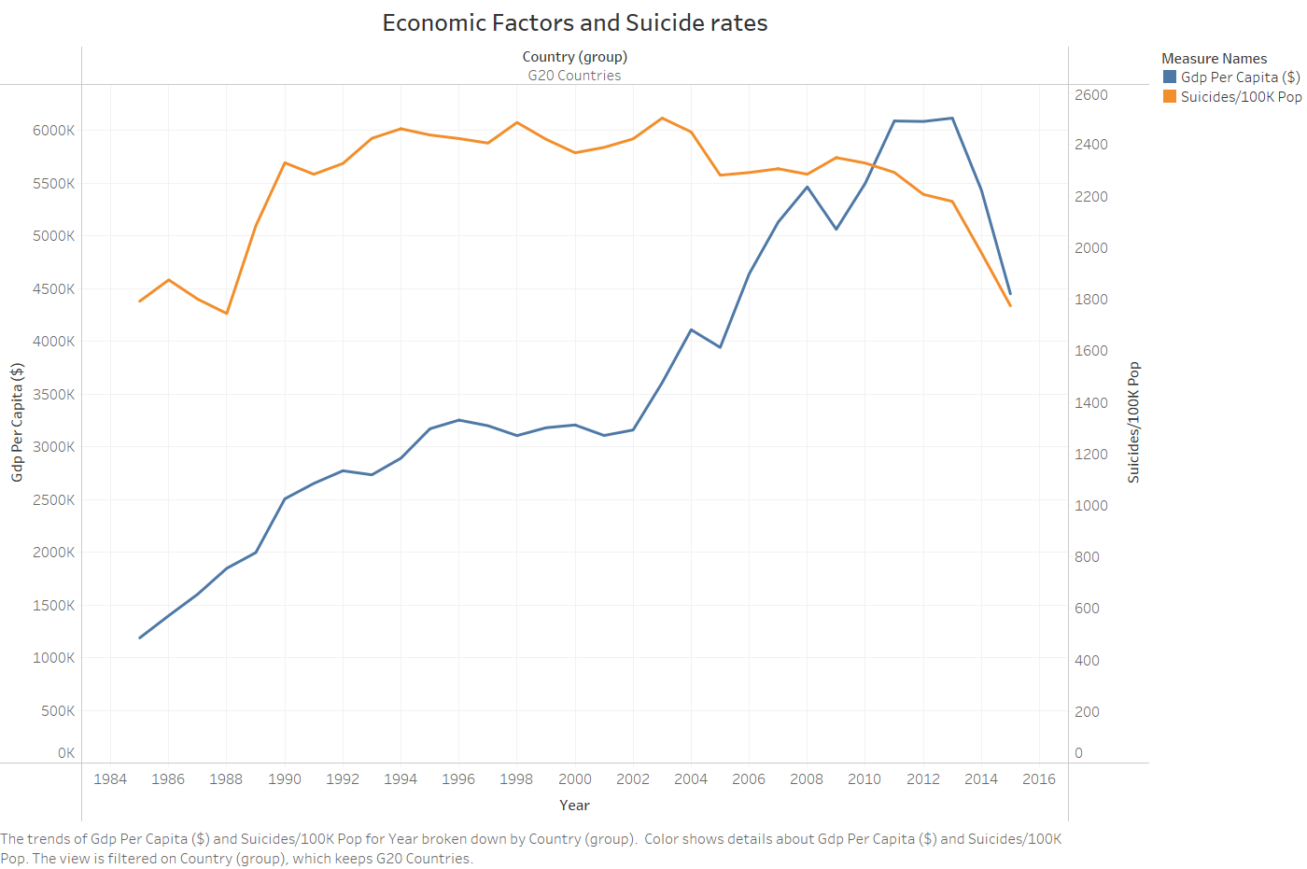

The line chart compares GDP per capita against suicide rates per 100,000 population in G20 countries from 1984 to 2016. It illustrates a general increase in GDP per capita, reflecting economic growth. Contrasting with this rise, the suicide rates fluctuate independently, without a clear or consistent response to economic progression.

This visual analysis underscores that higher economic status, as indicated by GDP per capita, does not necessarily correspond to lower suicide rates. Instead, the data reveals the complexity of suicide as a multifactorial issue that extends beyond economic well-being.

The chart suggests the need for multifaceted suicide prevention strategies that incorporate not just economic, but also mental health, social, and cultural considerations. It serves as an informative tool for understanding the nuanced relationship between economic factors and mental health outcomes, providing valuable insights for public health initiatives.

**Suicide Rates by Generation**

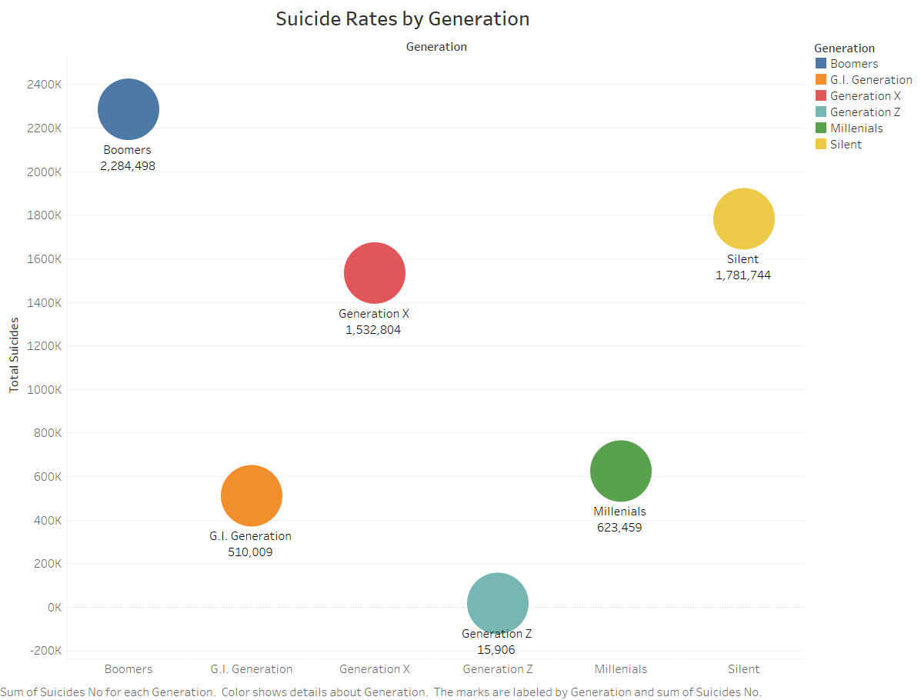

The bubble chart presents suicide rates categorized by generational cohorts, providing a comparative view of the total suicides associated with each group. The size of each bubble corresponds to the total number of suicides within that generation, with the Boomers experiencing the highest total at 2,284,498, followed by the Silent Generation with 1,781,744, and Generation X at 1,532,804.

The G.I. Generation, while having a smaller population size, shows a significant total as well, with 510,009 suicides. Millennials are represented with a considerably lower total of 623,459, which may be reflective of their younger age during the timeframe of data collection. Generation Z, being the youngest group, has the smallest bubble, indicating the fewest suicides at 15,906.

These generational insights are crucial for understanding historical and social factors that may influence suicide rates. The higher rates in older generations could be due to longer lifespans within the dataset or generational differences in coping mechanisms and societal pressures. For Millennials and Generation Z, their lower numbers point to the importance of current and future suicide prevention measures that are attuned to the unique challenges faced by these age groups. The data is instrumental in guiding targeted mental health strategies and public health policies to address the complex factors contributing to suicide across different generational cohorts.

**Country-Specific Insights**

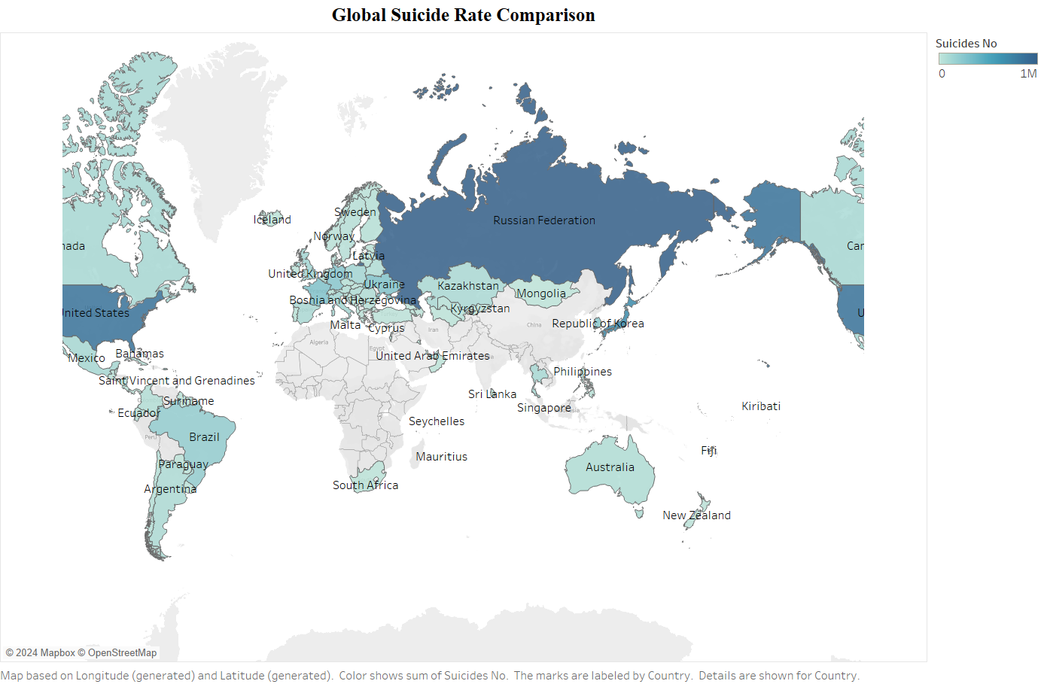

The world map visualization provides a comparative analysis of suicide rates across various countries, with color shading representing the total number of suicides. Darker shades indicate higher totals, offering a clear visual of the global distribution of suicide incidences.

From the visualization, it is evident that certain regions exhibit significantly higher suicide numbers. This distribution is key for understanding regional trends and potential cultural, economic, or policy factors that may influence these rates.

This global perspective is instrumental for public health officials and policymakers to identify areas with urgent needs for mental health support and suicide prevention resources. Additionally, it can prompt cross-country comparisons and collaborations to implement successful strategies from lower-rate regions in higher-rate areas.

The map underscores the importance of considering geographical and societal contexts in addressing the challenge of suicide, directing global efforts toward a more informed, sensitive, and effective approach to mental health crises.

**Generations suicide rate among country’s**

**G.I Generation**

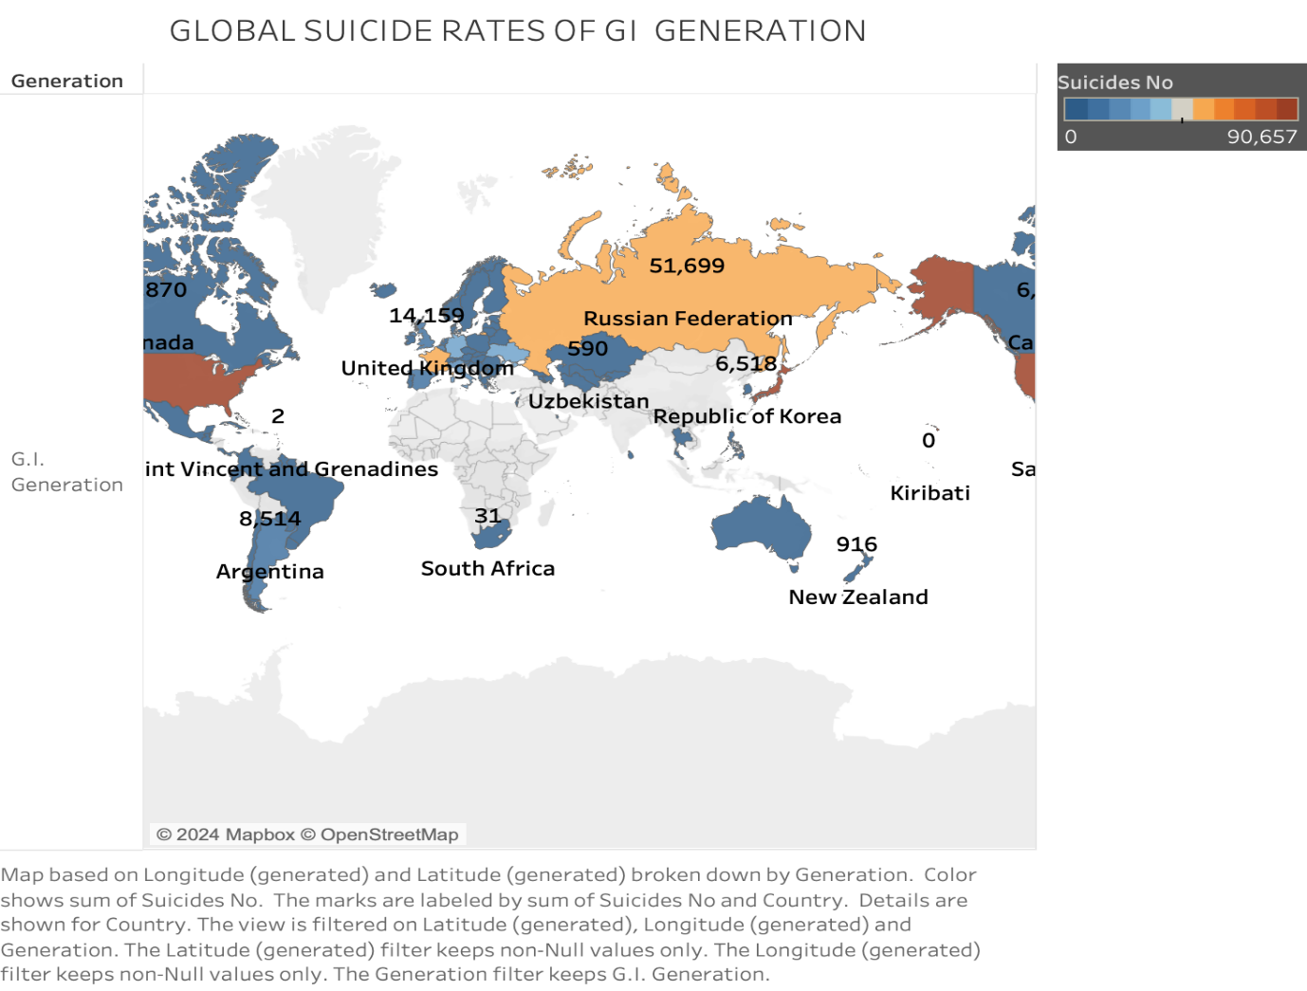

The above map visualizes the suicide rates of the G.I. Generation across different countries, with varying color intensities representing the scale of suicide numbers. It is immediately apparent that some countries face a much higher incidence of suicides within this generation than others. For instance, the Russian Federation shows a markedly high number of suicides, alongside other nations that are significantly impacted, albeit to a lesser extent.

This geographical distribution suggests a correlation between regional factors and the mental health of the G.I. Generation. The map not only serves as a stark reminder of the prevalence of suicide among the older generation but also as a call to action for tailored mental health services that cater to their specific needs.

Understanding the historical and societal contexts that may contribute to these numbers is crucial for developing effective interventions. This global overview aids in identifying focal points for in-depth research and resource allocation, enabling a targeted approach to mitigate the high rates of suicide observed in regions.

**Silent Generation**

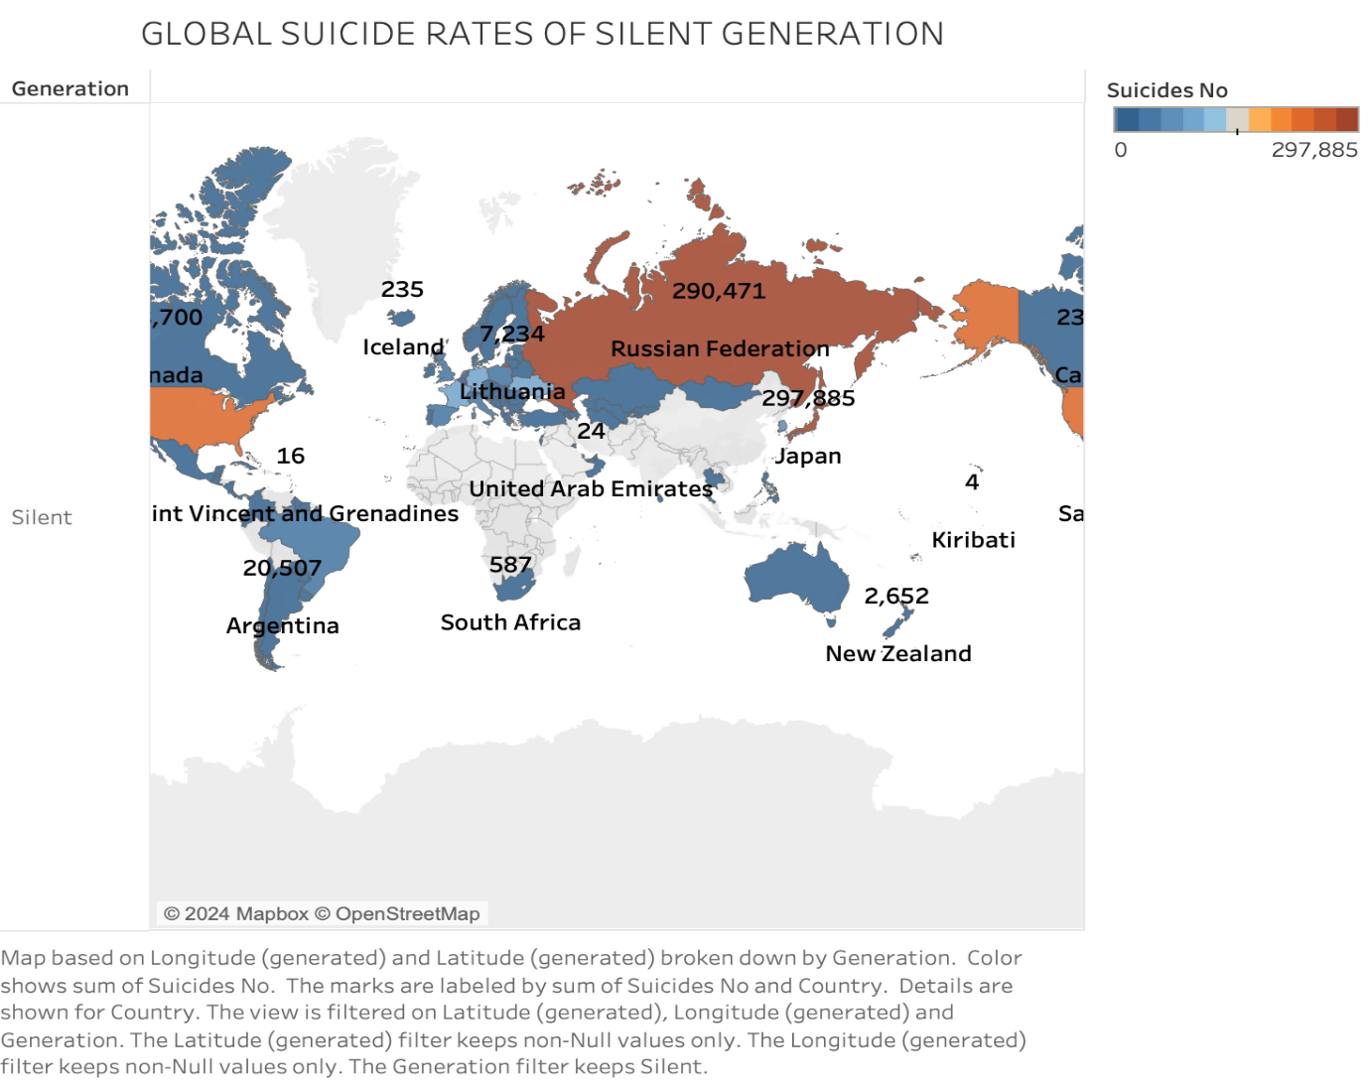

This map provides a visual depiction of suicide rates within the Silent Generation across the globe. The color gradations indicate the number of suicides, with darker shades representing higher numbers. The Russian Federation stands out with the highest number, closely followed by Japan, reflecting a significant public health concern in these regions for the age cohort born between 1928 and 1945.

Notably, Lithuania and Argentina also exhibit relatively high suicide numbers within this generation, while other countries like Iceland and the United Arab Emirates report significantly lower figures. The diversity in suicide rates suggests varying underlying factors at play, which may include economic conditions, social support systems, and access to healthcare.

The geographical spread of data brings attention to the need for region-specific mental health strategies tailored to the Silent Generation. This visualization emphasizes the importance of addressing the root causes and potential interventions to mitigate the impact of suicide on this demographic group.

**Boomer Generation**

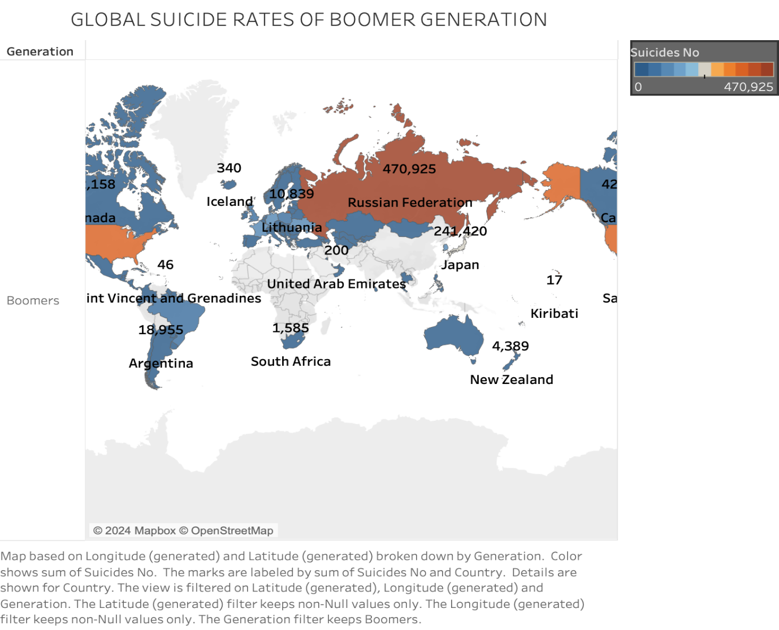

The map illustrates suicide rates within the Boomer generation across various nations, shaded to reflect the number of suicides. The Russian Federation exhibits the most substantial figure, followed by Japan, indicating these are areas with higher suicide incidences in this demographic, born between 1946 and 1964.

Other countries, such as Lithuania and Argentina, show notable suicide figures within the Boomer generation, although they are lower in comparison to the leading nations. Regions like Iceland and New Zealand, despite their contrast in geography and population, report lower numbers, which may reflect differences in societal structures, healthcare systems, and cultural attitudes towards mental health.

This global overview of suicide rates among Boomers draws attention to the necessity for age-specific mental health resources and preventative measures. Understanding the variances in suicide rates across countries can inform international efforts to address this issue and support the development of effective strategies to assist the Boomer generation as they advance in age. The visualization serves as a poignant reminder of the silent crisis affecting this generational cohort and the need for targeted interventions.

**Generation X**

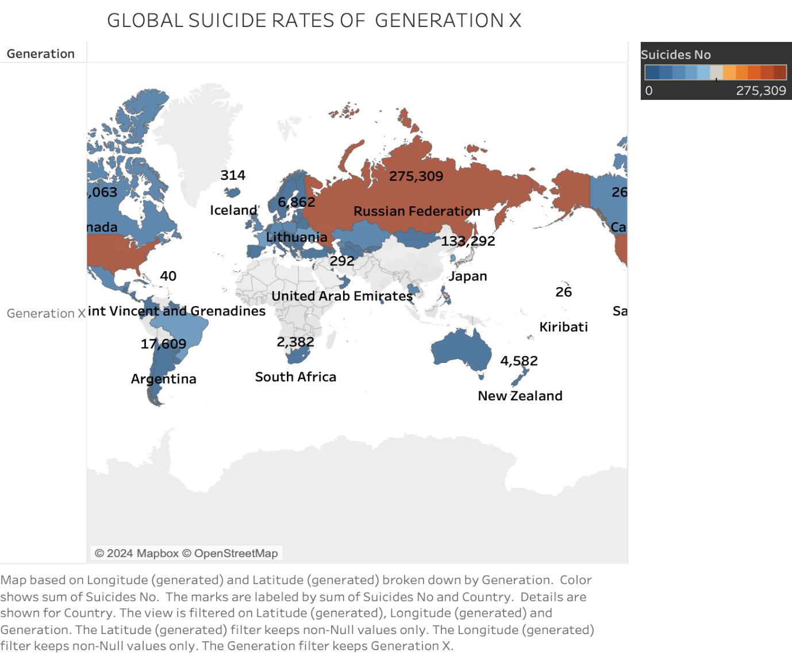

The map visualizes global suicide rates among Generation X, characterized by varying shades indicative of the suicide numbers in each region. The Russian Federation reports the highest number within this demographic, indicating a significant public health concern. Japan also shows a considerable number of suicides, although less than Russia, signifying another area of focus.

Lithuania and Argentina display notable totals as well, suggesting regional factors that may contribute to these figures. Meanwhile, countries like Iceland and the United Arab Emirates, though diverse in many aspects, report much lower suicide numbers for Generation X.

This representation provides a global snapshot of the challenges faced by Generation X about mental health. It underscores the importance of targeted suicide prevention efforts that are sensitive to the cultural, economic, and social variables influencing this generation. By identifying regions with higher suicide rates, health agencies, and policymakers can tailor interventions to address the specific needs of Generation X, considering the unique pressures and experiences that may affect their mental well-being. The visualization forms a crucial part of understanding the broader picture of global mental health trends for this age group.

**Millennials**

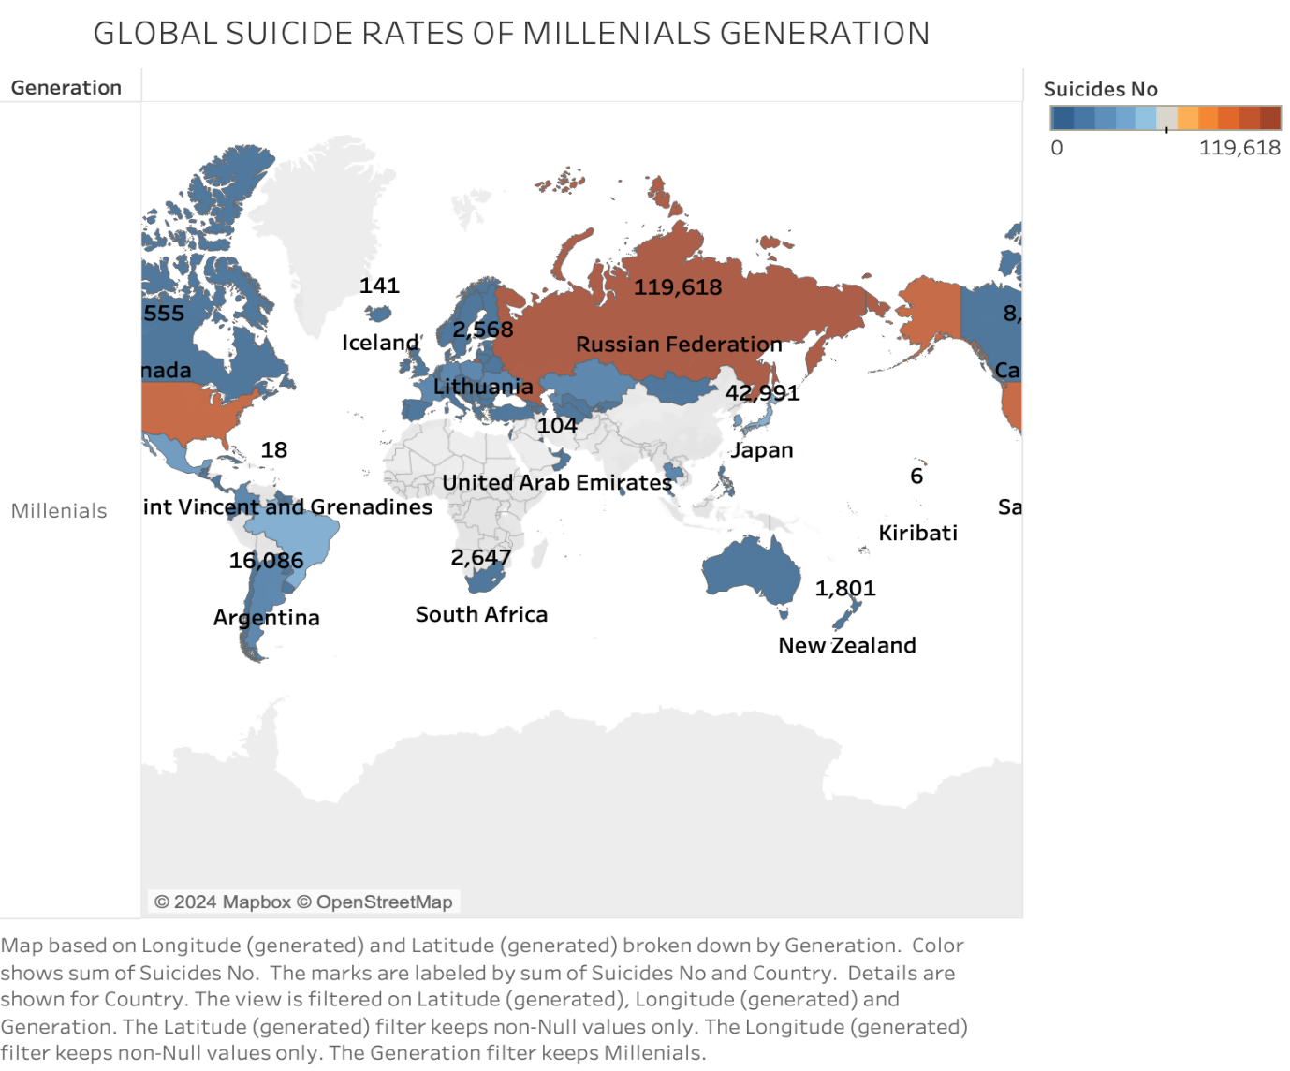

This map showcases the suicide rates of the Millennial generation globally, with color intensity representing the number of suicides. The Russian Federation emerges as the region with the most significant number of suicides among Millennials, followed by Japan, which indicates that these are key areas of concern within this generational cohort.

Other regions, such as Argentina and South Africa, show notable suicide figures as well, while countries like Iceland and the United Arab Emirates report much fewer instances. The variation in suicide numbers may reflect the differences in socioeconomic conditions, cultural factors, or access to mental health resources among Millennials in these countries.

The visualization is a vital component of our project, highlighting the need for a focused approach to mental health tailored to the Millennial generation's challenges. It emphasizes the importance of international mental health strategies that consider the diverse experiences and conditions of Millennials across the globe. By pinpointing regions with higher rates, the map aids in directing resources and preventive efforts where they are most needed, aiming to reduce the global burden of suicide on this younger generation.

**Generation Z**

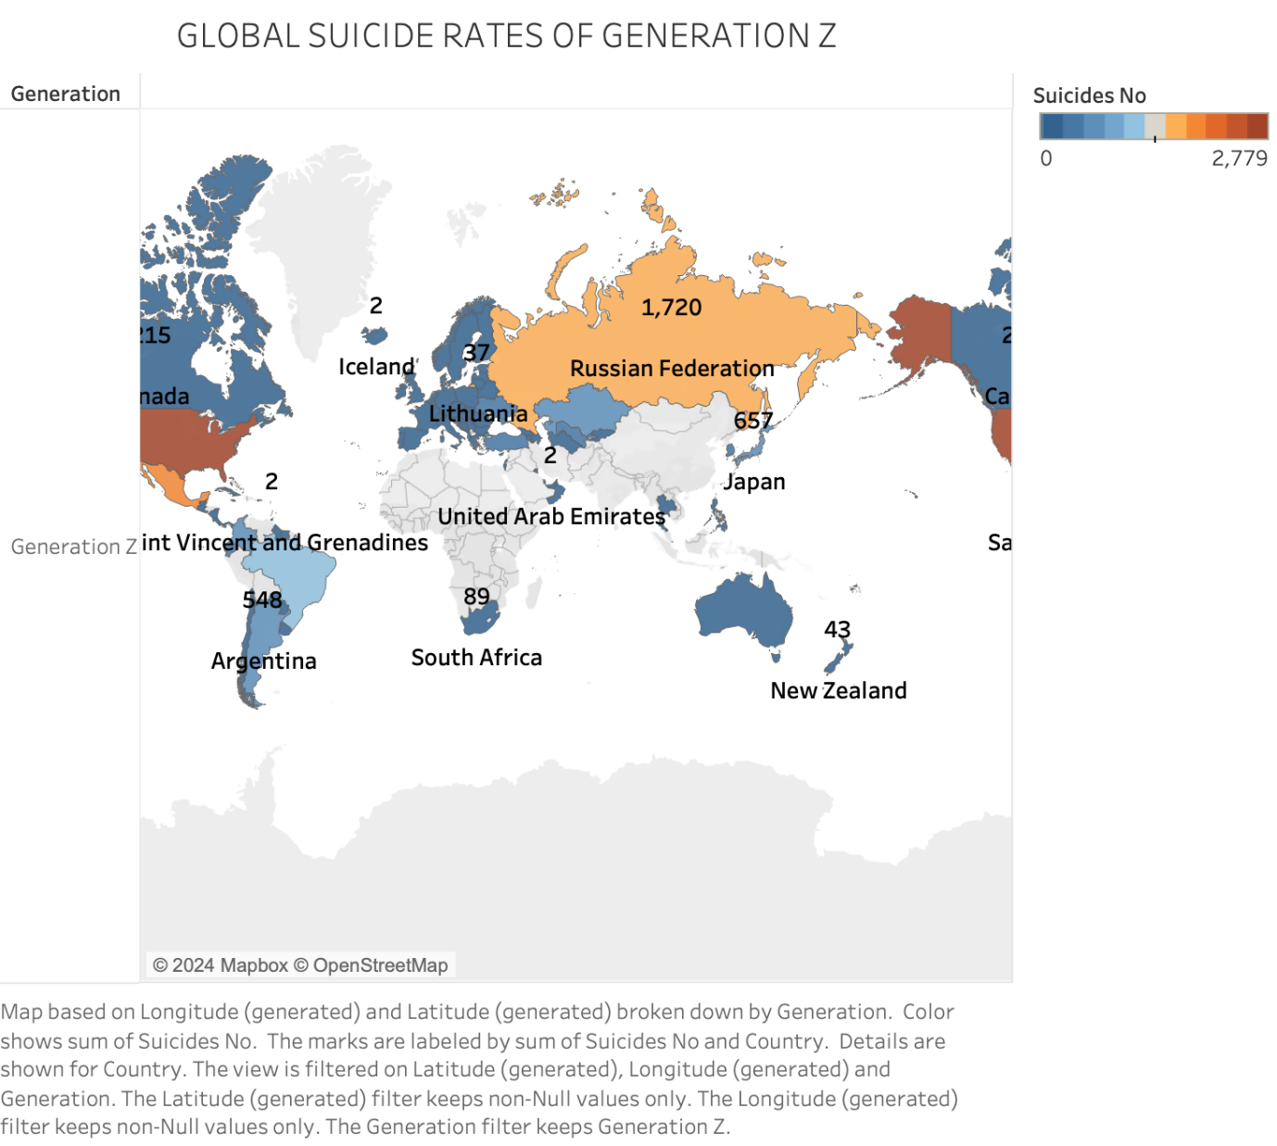

This map focuses on the global suicide rates for Generation Z, with each country's color intensity representing the total number of suicides within this young generation. The data suggests that the Russian Federation has the highest reported number, with Japan also showing a considerable count. Other nations, such as Argentina and South Africa, have lower numbers, but still notable given the youth of this generation.

The variation in suicide rates across countries could be influenced by factors such as access to mental health resources, cultural stigmas associated with seeking help, or the prevalence of social media and its impact on mental health. Noteworthy is the relatively lower number of suicides in countries like Iceland and the United Arab Emirates, which may reflect effective youth mental health policies or reporting differences.

These findings highlight the need for global awareness and proactive strategies to address mental health challenges faced by the youngest members of society. The map serves as a critical tool for identifying regions where mental health support for Generation Z may be particularly urgent and for sparking international dialogue on best practices for suicide prevention among youth.

**Analysis and Discussion**

Exploring the intricate relationship between suicide ratios and demographic variables unveils compelling patterns indicative of the multifaceted nature of suicide trends. Across diverse age groups, distinct trajectories in suicide ratios emerge, reflecting the varying stressors inherent to different life stages. Notably, a progressive increase in suicide ratios is observed with advancing age, with the 25-34 age cohort exhibiting a pronounced peak. This trend likely reflects the myriad challenges associated with transitioning from early adulthood to stable career phases, compounded by the responsibilities of family life. Interestingly, gender disparities in suicide ratios become more evident in older age groups, potentially influenced by demographic imbalances and differential coping mechanisms. The nuanced examination of suicide rates by generation and income group sheds further light on these dynamics, revealing intriguing patterns that underscore the evolving socioeconomic landscape's impact on suicide trends.

Delving deeper into generational disparities, older cohorts such as the G.I, Silent, and Baby Boomer generations exhibit elevated suicide rates, particularly among high-income populations. This phenomenon suggests complex interplays between socioeconomic status, generational attitudes, and access to mental health resources. Conversely, younger generations, including X, Millennials, and Z, display higher rates within low-income groups, indicative of shifting societal pressures and economic vulnerabilities. The analysis thus underscores the critical role of socioeconomic factors in shaping suicide trends across different generational cohorts, necessitating targeted interventions tailored to the unique needs of each demographic segment.

Furthermore, the exploration of economic performance's impact on suicide rates within G20 countries offers intriguing insights into the complex relationship between macroeconomic indicators and mental health outcomes. While most countries exhibit no discernible correlation between economic fluctuations and suicide rates, exceptions like Russia reveal intriguing patterns. Here, periods of economic instability coincide with elevated suicide rates, highlighting the profound impact of socioeconomic upheavals on population well-being. Conversely, periods of economic growth correlate with declining suicide rates, underscoring the potential protective effects of improved economic conditions on mental health outcomes. This nuanced understanding of economic determinants enriches our comprehension of suicide trends, emphasizing the importance of holistic approaches that address both socioeconomic disparities and mental health support systems.

In sum, the comprehensive analysis of suicide trends offers invaluable insights into the complex interplay of demographic, socioeconomic, and cultural factors shaping population well-being. By elucidating the nuanced dynamics underpinning suicide rates across different age groups, generations, and countries, this study lays the groundwork for targeted interventions and policy initiatives aimed at mitigating the prevalence of suicide and promoting mental health resilience on a global scale.